[Quick] Style Set Sampler – Title style
This is Quick Style Set Sampler.docx. This is the Subtitle style. Version 24.4
Charles Kenyon, Author See [Quick] Style Sets on my website
This document shows the twenty-five styles contained in the distributed [Quick] Style Sets. You can see the effect of applying one of the style sets by having the document open and holding your mouse pointer over one of the Style Sets in a Gallery (Design tab in Word 2013 and later).
Normal Style ¹

Heading 1³

Heading 2 ³

Heading 3 ³

Heading 4 ³

Heading 5 ³

Heading 6 ³

Heading 7 ³

Heading 8 ³

Heading 9 ³
No Spacing ¹

Title Style ³
SubTitle Style ³
Subtle Emphasis ²
Emphasis ²
Intense Emphasis ²
Strong ²
Quote ³
Intense Quote ³
Subtle Reference ²
Intense Reference ²
Book Title ²
List Paragraph¹
Caption¹
TOC Heading ¹

Types of Styles
¹ Paragraph Style
² Character Style
³ Linked Style

The styles in the three columns above show all the styles in the Simple [Quick] Style Set using the Office Theme. Note the Aptos font use, which comes from the Theme. This document was created in Word 365 Version 2404 in Safe Mode so shows defaults at that time.
See also my article: [Quick] Style Sets and Word Themes in Microsoft Word.
If you change the Theme or change to a different [Quick] Style Set, the look will change, sometimes dramatically. Use a copy of this document to experiment!
Here is a screenshot of the Standard Expanded [Quick] Styles Gallery:
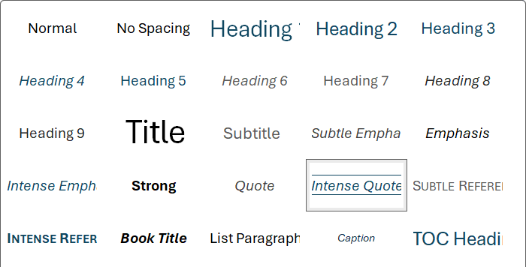

Themes will also change the appearance of any of the installed Quick Style Sets. They all use Theme fonts and colors. You can download my Theme sampler page which is similar to this but includes more colors and shapes from my downloads page.
This document is copyrighted. It may be distributed without further permission so long as it is distributed in its entirety without modification other than the application of a Quick Style Set and/or Theme to it. This is Version 24.4. Updates, if any, can be found on my downloads page.

